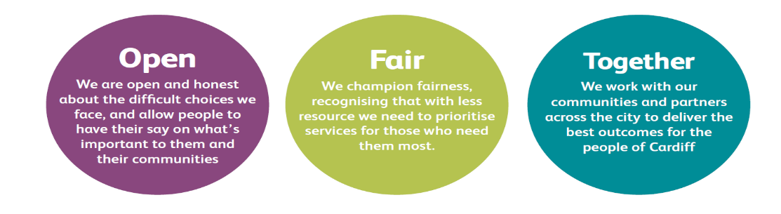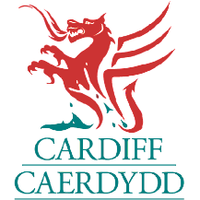
JOB DESCRIPTION AND PERSON SPECIFICATION

Job Title:  EURO 2028 – Project Coordinator | Directorate:  Economic Development
Section:  Economic Development | Reporting to:  EURO 28 – Project Lead
Grade: 5 | Hours per Week:  37 hours Mon to Friday – however actual hours will be as and when required to carry out the duties satisfactorily
Location of Post: Hybrid with 2 days per week working from County Hall, Cardiff
Job Purpose:

Cardiff is proud to host the opening match and five further fixtures of UEFA EURO 2028, welcoming hundreds of thousands of fans and showcasing the very best of our capital city to a global audience. To help deliver an event of this scale, Cardiff Council is seeking a Project Coordinator to provide high-quality administrative, organisational and secretariat support to the Project Lead and wider delivery team.

This role plays a key part in ensuring the smooth running of day-to-day project activity, supporting communication across workstreams, coordinating documentation and meetings, and helping maintain effective governance and project controls.

UEFA EURO 2028 represents a once-in-a-generation opportunity for Cardiff and Wales. This is your chance to help shape an event of international significance, drive lasting impact for local communities, and play a central role in transforming the city’s profile on the world stage.

Duties and Responsibilities

- Provide day-to-day administrative and organisational support to the Project Lead and wider team.
- Act as the first point of contact for general enquiries, directing queries and information appropriately.
- Manage diaries, schedule meetings, coordinate stakeholder engagements and support working groups.
- Prepare high-quality documents including agendas, minutes, presentations, reports and briefing notes.
- Support the maintenance of project documentation, trackers, risk registers and project plan.
- Assist with the coordination of multiple workstreams by ensuring information is accurate, up-to-date and shared in a timely manner.
- Support contract and supplier administration, including record keeping, raising purchase orders, dealing with invoices and timely payments.
- Provide secretariat support for governance meetings, including circulating papers and following up on actions.

- Assist with monitoring budgets, financial tracking and processing routine finance and HR paperwork.
- Maintain effective relationships with internal teams, partners, and external stakeholders such as UEFA and the UK & Ireland 2028 delivery team.
- Help organise meetings, site visits, workshops, events and operational planning sessions as required.
- Undertake any other administrative or coordination tasks necessary to support the successful delivery of Cardiff’s UEFA EURO 2028 obligations.

Corporate Requirements

- To champion Equality, Diversity and Inclusion (EDI) and Sustainability, embedding inclusive, accessible and environmentally responsible practices across all aspects of tournament planning and delivery.
- To take reasonable care for the health and safety of yourself and other persons who may be affected by your acts or omissions and to comply with all health and safety legislation as appropriate.
- Although you will be provided with a base, you will be required to work from various locations in accordance with the needs of the role.

Person Specification

Job Title: EURO 2028 – Project Coordinator

THE PERSON APPOINTED MUST MEET THE FOLLOWING REQUIREMENTS

Area to be Demonstrated | Essential Requirements  YOU MUST DEMONSTRATE THAT YOU MEET THESE REQUIREMENTS | Desirable Requirements | How Assessed  Application Form or Interview or Both
Experience / Knowledge | Proven experience providing administrative support in a busy, fast-paced environment.  Experience handling sensitive or confidential information appropriately.  Knowledge of basic project management processes and tools (trackers, risk logs, project plans).  Experience of coordinating meetings, preparing documentation and supporting governance activity.  Experience working with multiple stakeholders across different teams. | Knowledge of Cardiff and Wales.  Experience working on major events or large scale projects is highly desirable. | Application Form and Interview
Skills and  Abilities | Excellent communication skills, both written and verbal, with the ability to engage confidently with partners and stakeholders at all levels.  Strong organisational skills with exceptional attention to detail.  Ability to prioritise and manage multiple task across different workstreams.  Competent IT skills including MS Office applications (Word, Excel, PowerPoint, Teams and SharePoint).  Ability to work proactively and take ownership of routine tasks. |  | Application Form and Interview
Personal  Attributes | Calm, resilient and solutions focussed.  Ability to work under pressure and to tight time scales.  Commitment to delivering excellence and support a high-performing project team.  Flexible and adaptable approach to work with a willingness to support varied tasks as project needs evolve.  Self-motivated with a positive and collaborative approach. |  | Interview

