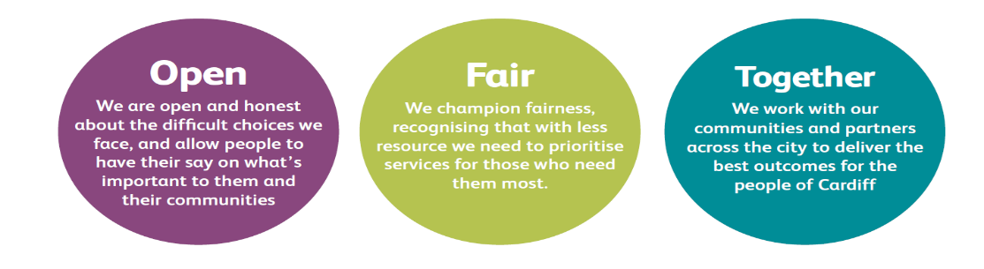
JOB DESCRIPTION AND PERSON SPECIFICATION

Job Title: Project Manager: EURO 2028 – Host City Project Lead | Directorate:  Economic Development
Salary: c£65k - £80k | Term: The role is expected to support Cardiff Council with the preparation & delivery of UEFA EURO 2028, as well as post-event completion requirements, and subject to extension.
Job Purpose:

Cardiff will be hosting the opening match, plus five further matches for UEFA EURO 2028, welcoming hundreds of thousands of fans to the city and broadcasting the city to an audience of millions globally.

To deliver its Host City Agreement Cardiff Council is building a team to deliver this world-class event and is seeking an exceptional Project Lead to oversee the city’s planning and delivery.

UEFA EURO 2028 is a once‑in‑a‑generation opportunity for the city and Wales, and you’ll join a team in a city that is proud of its reputation for hosting major international events. You’ll help shape a programme that delivers lasting benefits for communities, businesses and visitors, ensuring Cardiff showcases the very best of Wales to the world.

Duties and Responsibilities

- Lead Cardiff Council’s strategic planning and operational delivery for UEFA EURO 2028 as part of its Host City Agreement, and be responsible for ensuring that Cardiff Council meets the requirements of its Grant Funding Agreement.
- Co-ordinate the Host City activity across its areas of responsibility, including (but not restricted to) the fan festival sites, city dressing, volunteer programme, mobility, safety, security, and accessibility.
- Manage the Host City budget, including financial management and monitoring of the budget, managing claims and ensuring the Council is compliant with all financial requirements of the Host City Agreement.
- Ensure compliance with technical and governance requirements, and delivery of the project plan on time and on budget.
- Oversee the risk management of the host city delivery, working collaboratively with stakeholders to find operational and budgetary solutions.
- Build and oversee successful stakeholder relationships with funders and key delivery partners, such as The Football Association of Wales, the National Stadium of Wales, Welsh Government, UEFA, UK Sport, the UK&I 2028 local organising committee, and local delivery partners.
- Lead the Local Delivery Steering Group to ensure cohesive multi-disciplinary co-ordination across all city activity.
- Recruit, lead, manage and inspire the UEFA EURO 2028 Cardiff host city project team.
- Represent Cardiff City Council at operational meetings, championing the city’s interests.
- Co-ordinate all Council activity relating to UEFA EURO 2028.
- Ensure the project supports broader city goals, including community engagement, diversity, and economic growth.
- Work with key partners to deliver against the City’s and event’s EDI and sustainability goals.

Corporate Requirements

- To participate actively in supporting the principles and practice of equality of opportunity as stated in the Council’s Equal Opportunities Policy.
- To take reasonable care for the health and safety of yourself and other persons who may be affected by your acts or omissions and to comply with all health and safety legislation as appropriate.
- As a term of your employment you may be required to undertake such other duties and/or times of work as may reasonably be required of you, commensurate with your grade or general level of responsibility within the organisation.
- Although you will be provided with a base, you will be required to work from various locations in accordance with the needs of the role.

Person Specification

Job Title: Project Manager: EURO 2028 – Host City Project Lead

THE PERSON APPOINTED MUST MEET THE FOLLOWING REQUIREMENTS

Area to be Demonstrated | Essential Requirements  YOU MUST DEMONSTRATE THAT YOU MEET THESE REQUIREMENTS | Desirable Requirements | How Assessed  Application Form or Interview or Both
Experience / Knowledge | Extensive experience in planning and delivering large-scale and complex major events.  Proven ability to lead diverse teams and manage high-value budgets.  Experience in contract negotiation and programme delivery.  Experience in planning, governance, reporting, risk and dependency management.  Experience in managing multi-stakeholder projects and environments. | Knowledge of the events infrastructure of Cardiff and Wales.  Experience of delivering major international sporting events. | Application Form and Interview
Skills and  Abilities | Excellent interpersonal and communication skills and the ability to build successful relationships and trust with a wide range of partners.  Strong relationship-building skills across public, private, and community sectors.  Proven ability to lead multi-disciplinary, cross-organisational teams.  Proven ability to find creative and innovative solutions to complex problems, proactively identifying risks and working with a range of partners to implement sustainable, risk-aware solutions.  Ability to work under pressure and to tight time scales.  Takes a collaborative approach to partnership working |  | Application Form and Interview
Personal  Attributes | Strategic mindset with a focus on long-term outcomes.  Commitment to delivering excellence.  Self-motivated with a flexible and adaptable approach to work. |  | Interview

