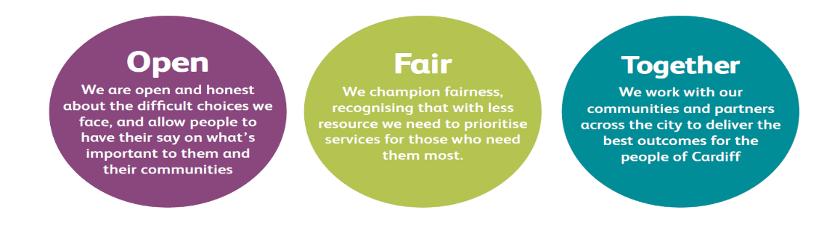

JOB DESCRIPTION AND PERSON SPECIFICATION

Job Title: Day Service Support Worker | Directorate: Adult Social Services
Section: Learning Disability Complex Needs Day Service | Reporting to: Day Service Officer/Senior Day Service Officer
Grade: 5 | Hours per Week:
Post Number: | Number of Employees  Reporting to Post: none
Special Conditions: | Location of Post: Cardiff Day Service, Pengam Road, Tremorfa
Job Purpose:
To work in the Complex Needs Day Service providing high quality, outcome led, person centred support to people with learning disabilities with complex support needs

Duties and Responsibilities
To provide high quality support to service users in line with the Day Service Plan prepared by the Day Service link worker.

Job Specific Requirement

- To support service users to enable them to achieve the outcomes outlined in the Day Service Plan.

- In consultation with the Link Worker, to liaise with families/carers to ensure understanding and consistency of the service provided.

- In consultation with the Link Worker, to liaise with other services as and when this is needed by service users.

- To attend to the personal and physical needs of service users where necessary in a respectful manner.

- To foster service users equality, diversity, rights and responsibilities.

- To carry out duties as agreed with the Day Service Officers using the resources available at the service base and in the community.

- To report to the Day Service Manager any concern regarding the wellbeing of service users in relation to the Vulnerable Adults Policy.

- To carry out tasks negotiated through supervision, or other relevant forum, within the agreed time span.

- To maintain appropriate records and to help compile reports in accordance with any format required by the County Council.

- To participate in staff meetings, staff development programmes and relevant training programmes.

Corporate Requirements
- To participate actively in supporting the principles and practice of equality of opportunity as stated in the Council’s Equal Opportunities Policy.

2. To take reasonable care for the health and safety of yourself and other persons who may be affected by your acts or omissions and to comply with all health and safety legislation as appropriate.

3. As a term of your employment you may be required to undertake such other duties and/or times of work as may reasonably be required of you, commensurate with your grade or general level of responsibility within the organisation.

4. Although you will be provided with a base, you will be required to work from various locations in accordance with the needs of the role.

DATE COMPLETED:_______________ AGREED BY: _____________________ (Recruiting Manager)

Date Received by Post holder: _____________________

Signature of Post holder: ____________________________

Person Specification

Job Title: Corporate Apprentice
Post Number:

THE PERSON APPOINTED MUST MEET THE FOLLOWING REQUIREMENTS

Area to be Demonstrated | Essential Requirements  YOU MUST DEMONSTRATE THAT YOU MEET THESE REQUIREMENTS | Desirable Requirements  YOU DO NOT HAVE TO MEET THESE REQUIREMENTS BUT IF YOU DO, PLEASE TELL US | How Assessed  Application Form or Interview or Both
Competencies (as per Behavioural Competency Framework) | Putting our Customers First – Level 2  Getting Things Done – Level 1  Taking Personal Responsibility – Level 2  Seeking to understand others, and treating them with respect - Level 1  Partnering and Corporate Working – Level 1  Communicating - Level 1 |  | Application Form & Interview
Education  & Training | Willingness to undertake relevant training to enhance skills and knowledge  Able to undertake manual handling training and to apply this within your day-to-day work  Able to undertake Positive Behavioural Support training and apply this within your day-to-day work  Able to undertake Positive Behavioural Management training and apply this to your day-to-day work | NVQ Level 2/ QCF care related award | Application Form & Certification where required
Experience / Knowledge | Experience of supporting people with a Learning Disability  Experience of supporting people with complex support requirements | Experience of working effectively to behavioural management plans  Experience of working within Day Services. | Application Form and Interview
Skills and  Abilities | Able to provide outcome led, person centred support  Able to provide support that maximises opportunities for independence  Able to effectively support people with a learning disability who have complex support needs including physical disabilities, autism, dementia and challenging behaviour.  Able to work to behavioural management plans including being able to use physical restraint if required after receiving relevant training  Able to respond sensitively to physical and intimate care requirements  Ability to complete accurate written records and reports | Able to communicate effectively with a wide variety of people using a range of methods such as BSL, Signalong, PECS etc.  Knowledge of person centred planning/thinking | Application Form and Interview
Personal  Attributes | Commitment to the values and ethics underpinning services  A commitment to equal opportunities  Reliable and punctual  Commitment to working effectively as part of a team  Proven literacy and numeric skills  Willing and able to support people at a variety of community based activities including ones which are physically active (swimming, cycling, gym session etc) |  | Application form and interview
Special  Circumstances | Must hold a full, valid driving licence and have access to a vehicle in which to transport service users  You must be available for work between the hours of 8.00am and 4.30pm Monday - Friday | . | Application Form and Interview

