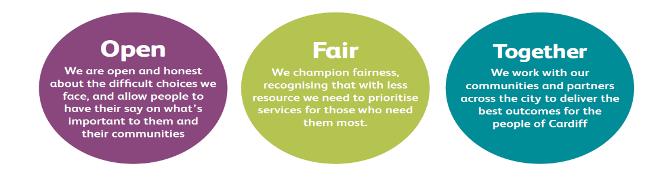

JOB DESCRIPTION AND PERSON SPECIFICATION

Job Title: Family Help Advisor | Directorate: Housing & Communities
Section: Early Help | Reporting to: Family Help Team Leader
Grade: 6 | Hours per Week: 37
Post Number: | Number of Employees  Reporting to Post: 0
Special Conditions:  Must possess a full driving license and have access to a car.  Must be available to work evenings and weekends in order to maximise the accessibility of services to families who are unable to attend normal daytime support. | Location of Post: Various locations across Cardiff.
Job Purpose:

The Family Help Adviser will be part of the Family Help home visiting team providing rapid interventions for families who without assistance may need more intensive support or safeguarding in the future.

The Family Help Adviser will be the key worker, responsible for identifying and assessing the well-being needs of the whole family, directly delivering short-term interventions and ensuring that all necessary support is in place to prevent clients requiring intensive assistance or the escalation to safeguarding teams.

Contributing to the achievement of the strategic and operational objectives of the Council and Early Help Service.

Duties and Responsibilities

Job Specific
As the keyworker, establish and maintain good relations with the client from their point of entry to their exit out of the Family Help Service.

Involving the family, undertake a whole family assessment using strengths based approach to identify both their assets and support needs and helping the family to develop an agreed way forward.

To identifying any well-being, financial, educational, relational and parenting requirements, assisting the family to resolve their own issues wherever possible.

Work to address the needs of clients including, where appropriate, the direct provision of advice and assistance on a range of issues, such as;
- parenting, supporting school attendance, welfare benefits, housing and money management;
- completing application forms or attending appointments with clients;
- assisting with the development of budget plans
- identifying entitlements to all types of benefit to maximise income for the family
- communicating with landlords as required;
- referral and follow up to other specialist services.

Ensure that any safeguarding concerns are identified and escalated in accordance with the Councils safeguarding policies.

Deliver parenting support on a one to one basis on specific topics, such as toileting, routines, eating habits, managing emotions for a teen, self-regulation, parenting programmes e.g. Triple P, Parent Nurturing Programme.

Prepare clients to take part in group sessions e.g. conduct home visits prior to group engagement to build confidence and to establish and support clients with barriers to engagement/attendance. Follow up after group based programmes, in order to assist parents in implementing what they have learnt in the group.

Support clients to access a wide range of specialist and community based services as required to address issues such as mental health, substance dependency, debt or unemployment. Encouraging and supporting clients to attend appointments and follow specialist treatment or advice.

Use motivational techniques to encourage families to engage with the support available, address their issues and build on their family relationships.

Deliver services that nurture and support the child/young person’s emotional and physical well-being, informed by best practice and supported by attending training and conferences as appropriate.

Manage client cases in line with current legislative requirements, including working with the client to develop an action plan with agreed measurable outcomes based on the clients identified needs. Regularly review with the client and evaluate progress.

Keep records of the distance travelled by clients using an approved tool and contribute to the services’ performance management systems.

Undertake timely and necessary liaison with other service areas, agencies and establishments, to secure services and interventions which ensure the client’s needs are addressed and outcomes achieved.

Keep the client informed of all actions and activities progressing their case and where appropriate, referral partners. Seek feedback from service users and ensure their full involvement in the monitoring and evaluation of practise.

Undertake relevant training and development to enhance performance.

Develop and maintain effective relationships with colleagues both internally and externally.

Attend meetings as and when required.

Corporate Requirements

To participate actively in supporting the principles and practice of equality of opportunity as stated in the Council’s Equal Opportunities Policy.

To take reasonable care for the health and safety of yourself and other persons who may be affected by your acts or omissions and to comply with all health and safety legislation as appropriate.

As a term of your employment, you may be required to undertake such other duties and/or times of work as may reasonably be required of you, commensurate with your grade or general level of responsibility within the organisation.

Although you will be provided with a base, you will be required to work from various locations in accordance with the needs of the role.

Contribute to the development, integration, evaluation and operation of the Council’s services and partnerships to drive forward customer care

Deliver the key messages to customers, partners, and key stakeholders to support the achievement of performance improvement, in compliance with legal requirements and in line with funding requirements.

Ensure compliance with all corporate policies, statutory requirements, ensuring full compliance with all aspects of operational health and safety and legislative requirements

Maintain an up to date knowledge of legislation, statutory frameworks and codes of practice to ensure statutory responsibilities are undertaken
DATE COMPLETED:_______________ AGREED BY: _____________________ (Recruiting Manager)

Date Received by Post holder: _____________________

Signature of Post holder: ____________________________

Person Specification

Job Title: Family Help Advisor (Grade 6)
Post Number:

THE PERSON APPOINTED MUST MEET THE FOLLOWING REQUIREMENTS

Area to be Demonstrated | Essential Requirements  YOU MUST DEMONSTRATE THAT YOU MEET THESE REQUIREMENTS | Desirable Requirements  YOU DO NOT HAVE TO MEET THESE REQUIREMENTS BUT IF YOU DO, PLEASE TELL US | How Assessed  Application Form or Interview or Both
Education  & Training | Evidence of continuous professional development  Must be able to demonstrate use of Microsoft Outlook, Word and Excel | A relevant professional qualification such as:  NOS Level 3 Working With Parents  Level 4 qualification in Advice and Guidance  Professional qualification in any of the following :  - Early Childhood Development  - Education (Early Years, Primary, secondary)  - Social Work  - Youth/Community Work  - Health | Application Form & Certification where required
Experience / Knowledge | Proven experience of working within a service team or project for children, young people and their families  Proven knowledge and experience of providing evidence based interventions for children, young people or their parents,  A wide understanding of housing, welfare benefits, money issues and the services available to assist with health issues such as mental health and substance misuse  Knowledge and understanding of child development.  Experience in dealing with, safeguarding issues in relation to children, young people and their families | Experience of carrying out evidence based programmes including parenting in the home of clients.  Experience of mentoring others and sharing knowledge to improve performance | Application Form and Interview
Skills and  Abilities | Able to undertake assessments of need and develop action plans  Able to undertake accurate and timely record keeping and produce written reports  Able to establish effective, professional working relationships  Able to understand and demonstrate an awareness of equal opportunities | Ability to communicate in a relevant additional language  Able to complete application forms/ budgeting plans with clients and understands specialist services available to help with debt/benefits. | Application Form and Interview
Personal  Attributes | Understands and has a commitment to a child’s rights approach  Communicates clearly and effectively  Have a nurturing and empathic approach  Possesses motivation, enthusiasm and drive that encourages clients to engage with service | Be flexible and open to change | Application Form and Interview
Special  Circumstances | Must possess a full driving license and have access to a car.  Must be available to work flexibly, including evenings and weekends | This post will require travel across all areas of the city of Cardiff | Application Form and Interview

