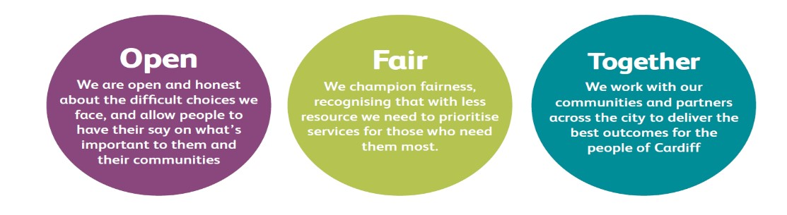

JOB DESCRIPTION AND PERSON SPECIFICATION
Job Title: Static Cleaner | Directorate: People & Communities / Housing & Communities
Section: Housing Services | Reporting to: Caretaking Supervisor
Grade: 1 | Hours per Week: 37
Post Number: TBC | Number of Employees Reporting to Post:
Special Conditions:  - Subject to DBS check  - Ability to get to place of work. | Location of Post: Mobile throughout City.
Job Purpose:

The Static Cleaner will be responsible for:

Providing high quality cleaning to communal areas of static blocks of flats within the city of Cardiff.
Duties and Responsibilities

- To provide a high quality Cleaning service, and taking full responsibility for specific tasks.

- To follow all cleaning procedures.

- To support the councils policies and procedures regarding Health and Safety and safe working practices.

- To risk assess areas or work and tasks to ensure a healthy and safe working environment for employees and public at large.

- Identify repairs and report the condition of communal areas of the block/s.

- Liase daily with Caretaking Supervisor, reporting on operational problems arising, including ASB or other tenancy issues.

- To provide clear written information to support work undertaken to aid the management team when providing answers to corporate complaints and for use during performance reviews.

- To ensure customer satisfaction, by working to improve customer service, and provide the highest quality of work in line with service level agreements.

- To communicate with customers and other service areas by telephone or in person as required.

- To undergo training and coaching and achieve BICSc training standards.

- To support the application of current and emerging technology.

Corporate Requirements
- To participate actively in supporting the principles and practice of equality of opportunity
as stated in the Council’s Equal Opportunities Policy.

- To take reasonable care for the health and safety of yourself and other persons who may be affected by your acts or omissions and to comply with all health and safety legislation as appropriate.

- As a term of your employment you may be required to undertake such other duties and/or times of work as may reasonably be required of you, commensurate with your grade or general level of responsibility within the organisation.

- Although you will be provided with a base, you will be required to work from various locations in accordance with the needs of the role.

DATE COMPLETED:_______________ AGREED BY: _____________________ (Recruiting Manager)

Date Received by Post holder: _____________________

Signature of Post holder: ____________________________

Person Specification

Job Title: Static Cleaner
Post Number:

THE PERSON APPOINTED MUST MEET THE FOLLOWING REQUIREMENTS

Area to be  Demonstrated | Essential Requirements  YOU MUST  DEMONSTRATE THAT  YOU MEET THESE  REQUIREMENTS | Desirable  Requirements  YOU DO NOT HAVE  TO MEET THESE  REQUIREMENTS BUT  IF YOU DO, PLEASE TELL US | How  Assessed  Application  Form or  Interview or  Both
Competencies  (as per  Behavioural  Competency  Framework) | - Putting Our Customers First – Level 1  - Getting Things Done –Level 1  - Taking Personal Responsibility – Level 1  - Seeking to understand others and treating them with respect – Level 1 |  | Application  Form &  Interview
Education  & Training | Demonstrates literacy & numeracy skills | Possesses a professionally recognised cleaning qualification | Application  Form &  Certification where required
Experience /  Knowledge |  | Experience of working in a domestic or commercial cleaning environment.  Experience of working with customers.  Experience in use of industrial cleaning equipment. | Application  Form and  Interview
Skills and  Abilities | Demonstrates the ability to communicate well in a manner appropriate to individual needs, by phone or in person.  Demonstrates the ability to apply a methodical approach.  Demonstrates the ability to work as part of a team, showing a willingness to assist others and a commitment to meeting the objectives of the team.  Demonstrates the ability to work unsupervised. |  | Application  Form and  Interview
Personal  Attributes | Shows a personal commitment to the work of the service, taking ownership of tasks and seeking to meet set deadlines and targets.  Demonstrates a commitment to the provision of a high quality customer service and shows a good understanding of equality issues.  Demonstrates a positive attitude to new challenges and a willingness to adapt quickly to change. |  | Interview
Special  Circumstances | Out of hours working | Full and valid driving licence and use of own car would be an advantage | Application  Form and  Interview

