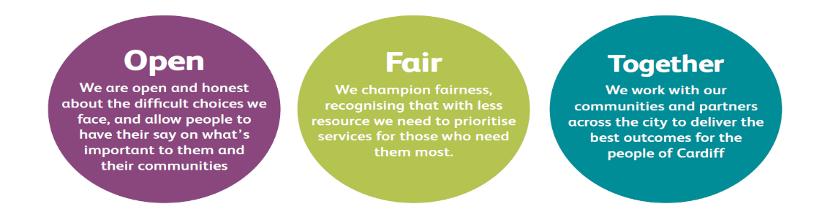

JOB DESCRIPTION AND PERSON SPECIFICATION

Job Title: Licensing Officer (Rent Smart Wales) | Directorate: Resources
Section: Rent Smart Wales | Reporting to: Rent Smart Wales Group Leader
Grade: 4 | Hours per Week:  37 – shifts will be based on a rota and may be variable according to business needs
Post Number: | Number of Employees  Reporting to Post: 0
Special Conditions:  Able to work on rota basis between the hours of 8am – 8pm and a Saturday morning if required. | Location of Post: County Hall
Job Purpose:

The Licensing officer will be responsible for understanding, supporting and advising landlords, agents and tenants and training companies, who will be making enquiries about Rent Smart Wales (a national landlord registration and licensing scheme) through multiple channels of access.
The Licensing officer will be responsible for resolving a high level of calls and enquiries and processing registration and licensing applications.
To consider, determine and issue registration and licences in accordance with the Service’s procedures

Duties and Responsibilities

Job Specific Requirements
1. To provide accurate, meaningful and consistent advice to customers, ensuring that they understand their legal obligations and the action which they should take. In all aspects of work to maintain accurate records.

2. To listen patiently, to empathise with the customer’s situation and convey a genuine desire to help and support. To ensure that the customer is clear about what you will act on following the contact.

3. To work with colleagues within the Rent Smart Wales team, Cardiff Council and contacts across the 22 local authority areas to ensure the highest levels of first time call resolution and customer satisfaction.

4. To process, validate information, recommend for decision and issue registration and licences, in accordance with the Service’s procedures. In all aspects of work to maintain accurate records.

5. To undertake verification checks and maintain and produce statistics to facilitate the efficient operation of the service and to ensure that records are kept up to date and accurate.

6. To record and process any payments received by any method, in accordance with the Service’s procedures.

7. To deliver a consistently high quality service by implementing agreed procedures and actively participating in service improvement.

8. To work with current and emerging technology to enhance the customer experience.

Corporate Requirements
- To participate actively in supporting the principles and practice of equality of opportunity as stated in the Council’s Equal Opportunities Policy.

- To take reasonable care for the health and safety of yourself and other persons who may be affected by your acts or omissions and to comply with all health and safety legislation as appropriate.

- To, as a statutory duty, adhere to the Council’s Corporate Safeguarding Policy and associated policies and procedures and to report concerns regarding the safety and wellbeing of children or adults at risk. In order to support you in this, you are required to access safeguarding training at the level which is relevant to this post.

4. As a term of your employment you may be required to undertake such other duties and/or times of work as may reasonably be required of you, commensurate with your grade or general level of responsibility within the organisation.

5. Although you will be provided with a base, you will be required to work from various locations in accordance with the needs of the role.

DATE COMPLETED:_______________ AGREED BY: _____________________ (Recruiting Manager)

Date Received by Post holder: _____________________

Signature of Post holder: ____________________________

Person Specification

Job Title: Licensing Officer (Rent Smart Wales)
Post Number:

THE PERSON APPOINTED MUST MEET THE FOLLOWING REQUIREMENTS

Area to be Demonstrated | Essential Requirements  You must demonstrate that you meet these requirements | Desirable Requirements  You do not have to meet these requirements but if you do, please tell us | How Assessed  Application Form, Interview, or both
Competencies (as per Behavioural Competency Framework) | Putting Our Customers First: 1  Understand who our customers are. Be Polite, Helpful and take time to listen to customers. Work with colleagues to help meet customer needs  Getting Things Done: 1  Ensuring tasks are completed to high standard and see them through to completion. Contributing to ensure efficient ways of working. Monitoring and checking own progress against requirements  Taking Personal Responsibility: 2  Continuing to deliver when faced with tough circumstances, uncertainty, difficulty or change. Supporting and encouraging others to deal with uncertainty, difficulty or change. Encouraging others to be fair, open and honest  Seeking to understand others and treating them with respect: 1  Asking about others’ views and feelings, and actively listening and acknowledging these. Acknowledging and considering the different views and ideas of others. Checking own understanding of how others feel |  | Application Form & Interview
Education  & Training | A sound working knowledge of using software within a MS Windows (or similar) environment and a Web based database environment. | Undertaken the accredited training course for Rent Smart Wales | Application Form & Certification where required
Experience / Knowledge | Keyboard skills demonstrating speed and accuracy whilst in a MS Windows (or similar) environment.  Experience in delivering customer information and advice services  Preparation of statistics and management information. | An understanding of Part 1 of the Housing (Wales) Act 2014, and it’s subordinate legislation.  Demonstrable experience in delivering customer focused information and advice services in one or more ethnic minority languages.  Proven experience delivering customer focused information and advice services  Demonstrable experience of implementing a variety of payment methods | Application Form and Interview
Skills and  Abilities | Advising – Provides accurate, meaningful and consistent advice to customers, clearly laying out the steps that will be taken by each party.  Building Rapport – Listens patiently empathises with the customer’s situation and conveys a genuine desire to help and support.  Team working – Is positively committed to the success of the team: promoting supportive relationships, sharing information and being sensitive to others.  Analysing & Understanding – Analyses complex and detailed information taking account of operating procedures and arrives at logical conclusions.  Ability to work accurately to strict deadlines. | Communicating Effectively – Communicates clearly, concisely and appropriately: gets the message across to a wide range of customers and colleagues.  Making the Most of Technology Makes best use of available technology & demonstrates an aptitude for learning to use new technologies to improve own performance.  Demonstrating Resilience – Demonstrates resilience to stress, maintaining effective performance in pressurised conditions. Able to remain focused during busy periods. | Application Form and Interview
Personal  Attributes | Demonstrating Commitment – Demonstrates a ‘can do’ attitude, initiative, enthusiasm and a responsible approach to all tasks  Equal Opportunities –  Demonstrates a commitment to equal opportunities | Contributing to Change – Contributes creatively to change processes, demonstrates and adaptable attitude and responds constructively to new ways of doing things.  Negotiating – Presents pertinent issues and facts in a persuasive manner, helping customers to see the most construction way forward. | Application Form and Interview
Special  Circumstances | The Service is open between the hours of 8am – 8pm and an appropriate shift pattern is in place.  Shift patterns are subject to review. |  | Application Form and Interview

