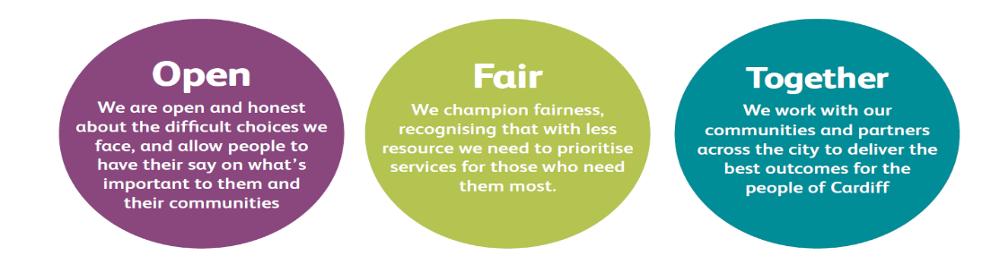

JOB DESCRIPTION AND PERSON SPECIFICATION

Job Title: Trainer | Directorate: People and Communities
Section: Advice and Benefits | Reporting to: Advice Coordinator
Grade: 6 | Hours per Week: 37
Post Number: | Number of Employees  Reporting to Post:
Special Conditions: Location of post may vary depending on the needs of training | Location of Post: Dominions Way
Job Purpose: To provide Training/Support and Quality checks of work relating to Advice and Benefits

Duties and Responsibilities

Job Specific Requirements
- To assist with the provision of a high quality Advice and Benefits Service

- To provide training relating to Advice and Benefits and any related issues, to individuals and groups.

- To train, support and quality check staff, for Advice and Benefits, where required, ensuring that staff receive appropriate training and support.

- To co-ordinate training for staff, organising the provision of training from other organisations and sections as required.

- To provide quality checking as required for statistical purposes and for management, Undertake checking in Performance Reviews and Competency issues and report on findings regularly.

- To set clear standards to ensure excellent customer service is achieved, to encourage customer feedback and to ensure that any complaints received are fully addressed and resolved.

- To ensure that a high quality customer service is provided.
- To communicate with customers, Members and other stakeholders and to attend meetings with interested parties as required.

- To be actively involved in any further training undertaken and to achieve Assessor Status if required.

- To assist in the Recruitment, Selection and Induction of staff

- To assist with the preparation of individual training plans and to provide feedback to managers about training needs

- To assist with the testing and development of computer software and to provide training and advice on the proper use of computer systems

- To independently develop and deliver training courses.

- To assist as required with the development and maintenance of procedures and help ensure that staff are kept up to date with legislative and procedural changes.

- To check benefit claims for accuracy and quality as required and to report on findings. Also that Advice and benefit procedures are being followed correctly and report on findings.

- To provide assistance and support to other staff and managers regarding the interpretation of Advice and Benefits legislation and procedures and the correct operation of computer systems.

- To play an active part in the Advice Team, ensuring that good communication is maintained within the team, providing cover for other officers and contributing to the work of the team as a whole.
- To communicate with customers and other interested parties in writing, by telephone, in office interviews and to visit customers in their homes as required.

- To seek to ensure customer satisfaction, by working to improve customer service, and resolve customer complaints.

- To practically assist in the co-ordination and operation of any Quality systems adopted by the service area.

- To carry out any general office duties as reasonably required including maintaining all necessary records and to providing monitoring information as required.

- To actively support the development of current and emerging technology.

- To assist in the Recruitment, Selection and Induction of staff

- To participate in supporting the principles and practice of equality of opportunity as laid down in the organisation's Equal Opportunities Policy.
- To take reasonable care for the health and safety of yourself and other persons who may be affected by your acts and omissions and to comply with all health and safety legislation as appropriate.

- As a term of your employment you may be required to undertake such other duties and/or times of work as may reasonably be required of you, commensurate with your grade or general level of responsibility within the organisation.

This appointment is made within the People and Communities Service area and the post holder may be required to move his/her workplace.

Corporate Requirements
- To participate actively in supporting the principles and practice of equality of opportunity as stated in the Council’s Equal Opportunities Policy.

- To take reasonable care for the health and safety of yourself and other persons who may be affected by your acts or omissions and to comply with all health and safety legislation as appropriate.

- To, as a statutory duty, adhere to the Council’s Corporate Safeguarding Policy and associated policies and procedures and to report concerns regarding the safety and wellbeing of children or adults at risk. In order to support you in this, you are required to access safeguarding training at the level which is relevant to this post.

4. As a term of your employment you may be required to undertake such other duties and/or times of work as may reasonably be required of you, commensurate with your grade or general level of responsibility within the organisation.

5. Although you will be provided with a base, you will be required to work from various locations in accordance with the needs of the role.

DATE COMPLETED:_______________ AGREED BY: _____________________ (Recruiting Manager)

Date Received by Post holder: _____________________

Signature of Post holder: ____________________________

Person Specification

Job Title: Advice and Benefits Trainer
Post Number:

THE PERSON APPOINTED MUST MEET THE FOLLOWING REQUIREMENTS

Area to be Demonstrated | Essential Requirements  YOU MUST DEMONSTRATE THAT YOU MEET THESE REQUIREMENTS | Desirable Requirements  YOU DO NOT HAVE TO MEET THESE REQUIREMENTS BUT IF YOU DO, PLEASE TELL US | How Assessed  Application Form or Interview or Both
Competencies (as per Behavioural Competency Framework) | - Putting Our Customers First – Level 3  - Getting Things Done – Level 2  - Taking Personal Responsibility – Level 2  - Seeking to understand others and treating them with respect – Level 3 |  | Application Form & Interview
Education  & Training | Demonstrates knowledge of Advice and Benefits related legislation. | A relevant professional /qualification | Application Form & Certification where required
Experience / Knowledge | Experience of working within a Benefits or Advice related environment.  Experience of using new technology.  Experience of supporting others and providing informal training and advice. | Experience of developing new technology.  Experience of providing formal training on a group and individual basis. | Application Form and Interview
Skills and  Abilities | Demonstrates a good knowledge and understanding of Advice and Benefits legislation.  Demonstrates the ability to present information to groups in a clear manner and using appropriate technology.  Ability to check the work of others and provide constructive feedback on an informal and formal basis.  Demonstrates the ability to communicate well in a manner appropriate to individual needs, by phone in person or in writing.  Demonstrates the ability to work as part of a team, showing a willingness to assist others and a  Commitment to meeting the objectives of the team.  Demonstrates the ability to apply a methodical approach and to follow complex procedures. |  | Application Form and Interview
Personal  Attributes | Commitment to the Council’s Equal Opportunities Policy  Shows a personal commitment to the work of the service, taking ownership of tasks and seeking to meet set deadlines and targets.  Demonstrates commitment to personal development and self-learning.  Able to work using own initiative and also use own discretion appropriately.  Demonstrates a commitment to the provision of a high quality customer service and shows a good understanding of equality issues.  Demonstrates a positive attitude to new challenges and a willingness to adapt quickly to change. |  | Application Form and Interview
Special  Circumstances | Attend meetings out of office hours as and when necessary.  Will undertake such other duties and/or times of work as may reasonably be required of you | Full driving license and use of own car would be an advantage. | Application Form and Interview

